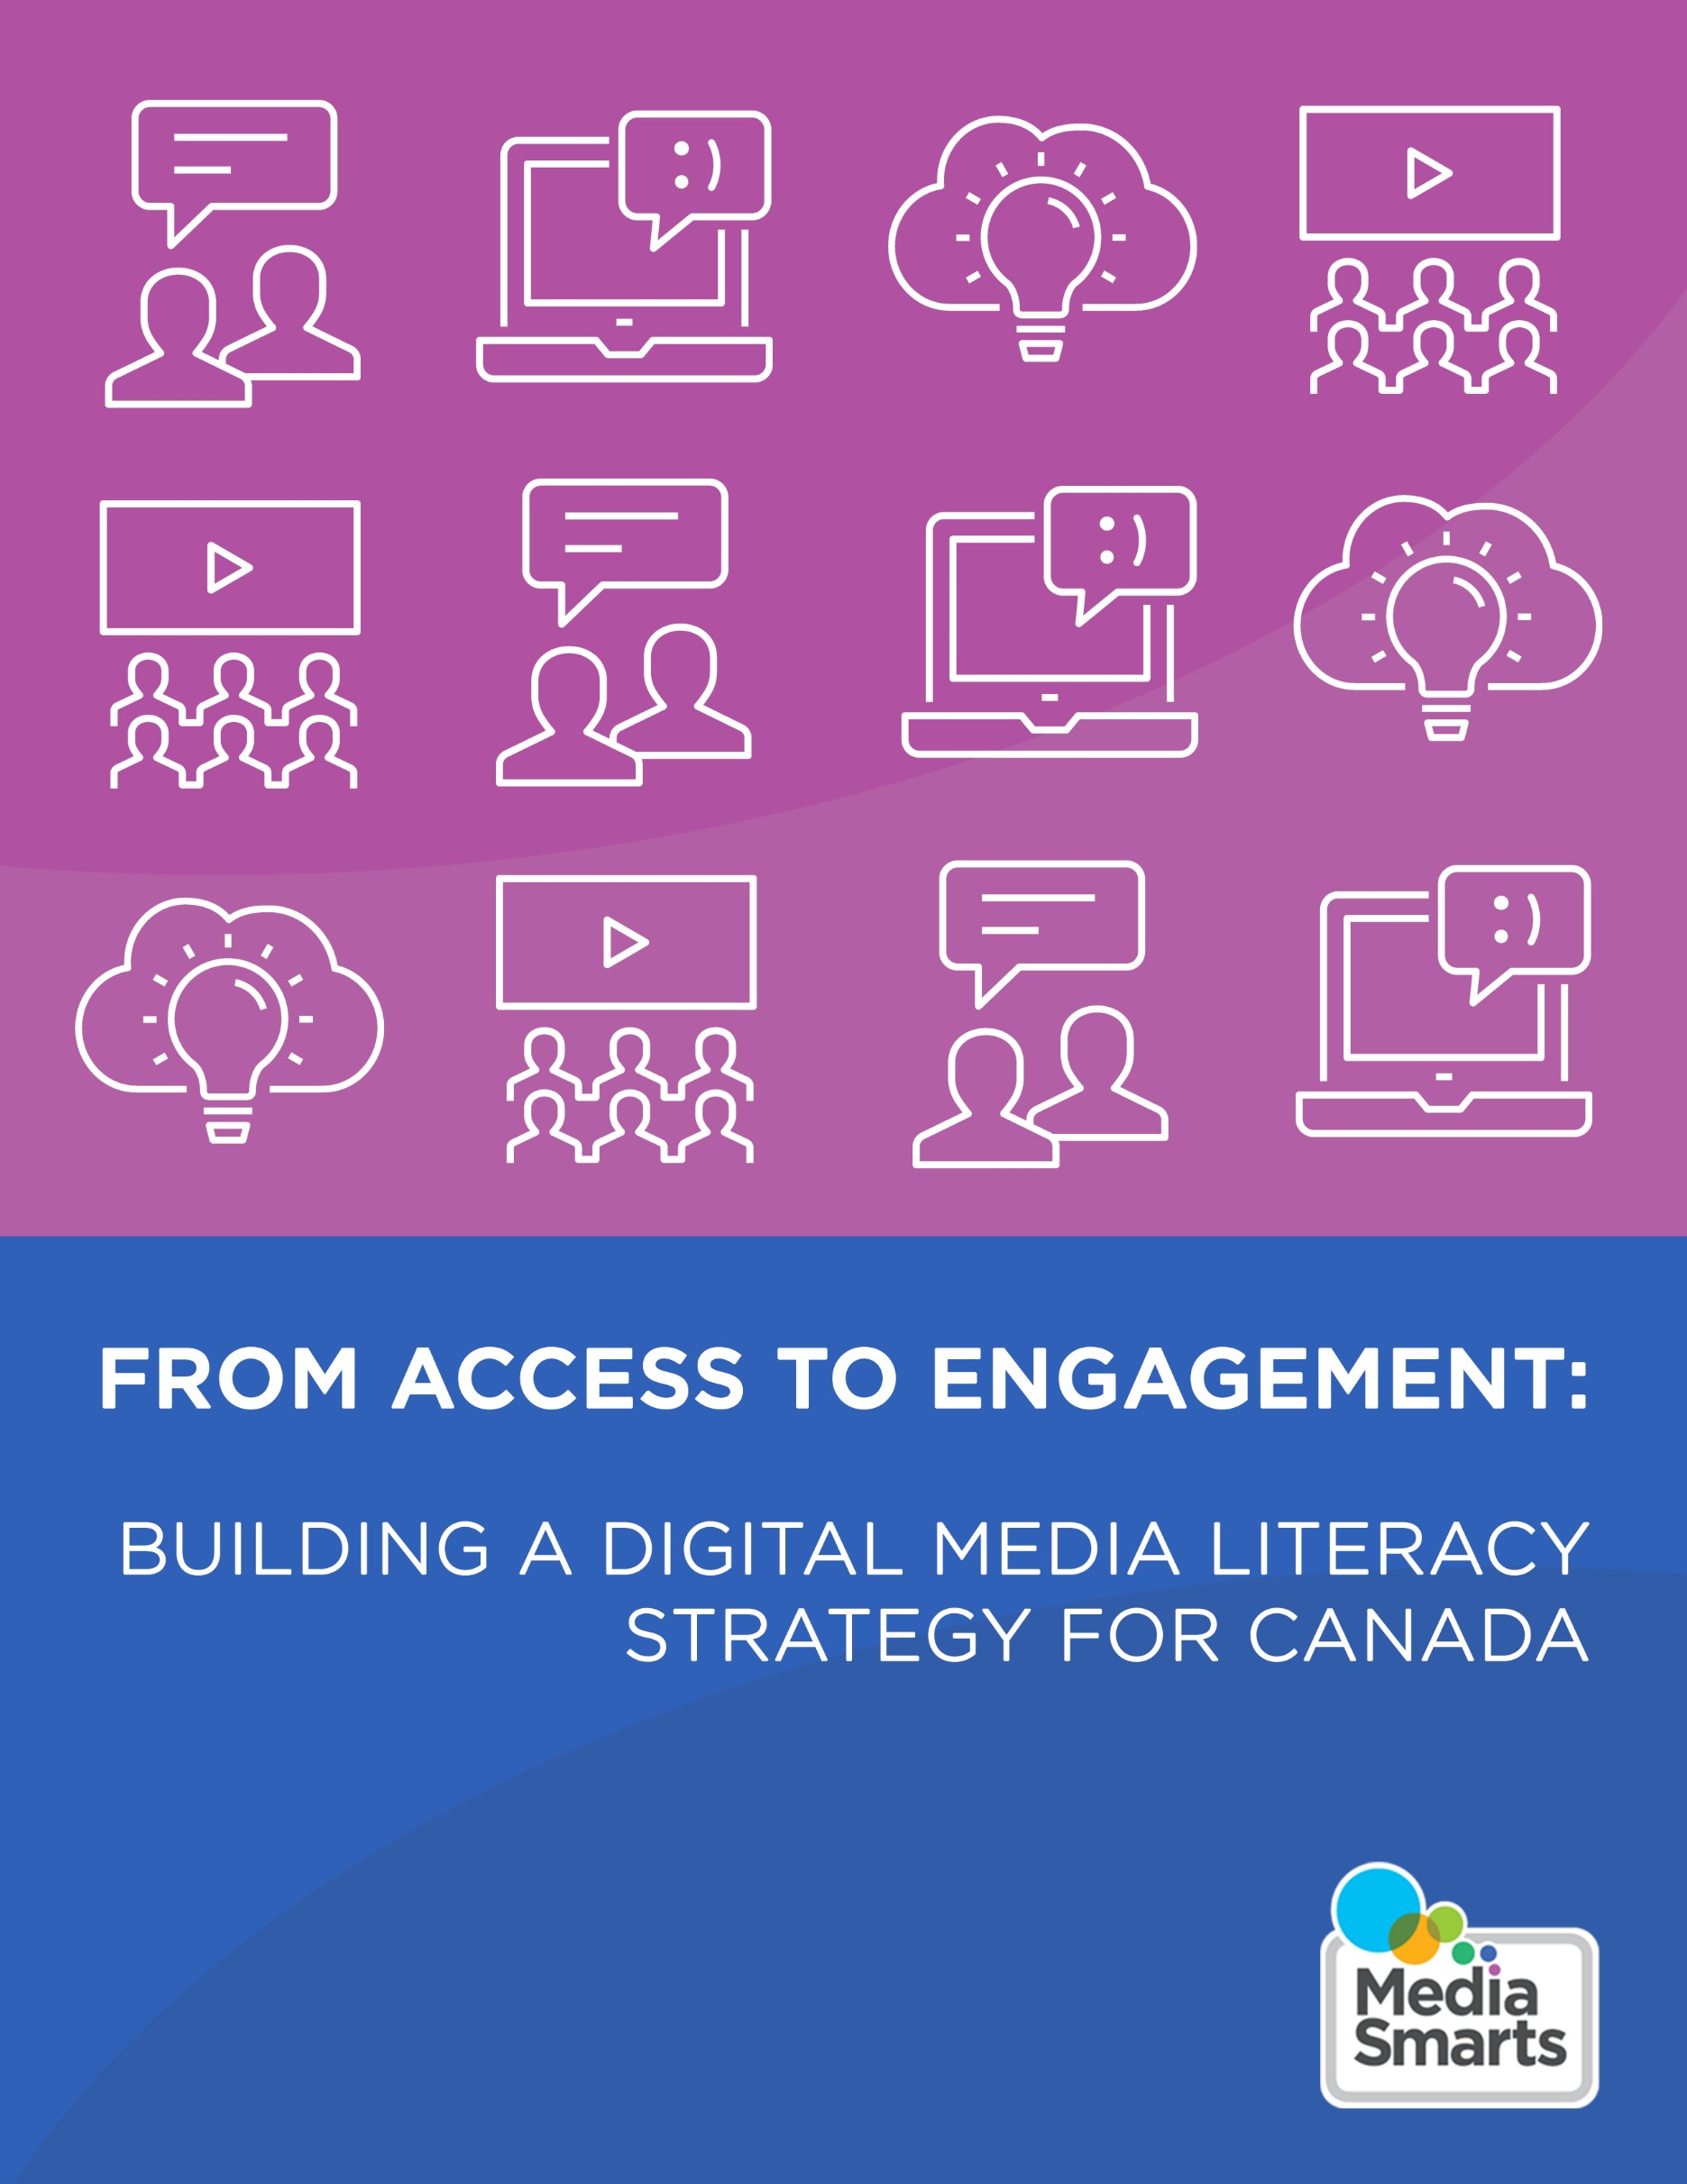

CANADA ' S CENTRE FOR DIGITAL AND MEDIA LITER ACY
Me•d•ia Smarts

From Access to Engagement: Building a Digital Media Literacy Strategy for Canada

Finance par le gouvernement du Canada ana a
Funded by the Government of Canada I C a···

MediaSmarts

MediaSmarts is a Canadian not-for-profit charitable organization for digital and media literacy. Our vision is that people across Canada have the critical thinking skills to engage with media as active and informed digital citizens. MediaSmarts has been developing digital and media literacy programs and resources for Canadian homes, schools and communities since 1996. MediaSmarts also conducts and disseminates original research that contributes to the development of our programs and resources and informs public policy on issues related to digital media literacy.

Website:

mediasmarts.ca

Report Key Contact:

Dr. Kara Brisson-Boivin Director of Research
kbrisson-boivin@mediasmarts.ca

Report Credits Symposium organizers:
Dr. Kara Brisson-Boivin, Director of Research, MediaSmarts
Samantha McAleese, Research and Evaluation Associate, MediaSmarts

Symposium design consultant and lead facilitator: Farhaan Ladhani, CEO, Digital Public Square Breakout group facilitators:
Rebecca Boucher, Media Education Specialist, MediaSmarts Dr. Kara Brisson-Boivin, Director of Research, MediaSmarts
Tricia Grant, Manager of Marketing and Communications, MediaSmarts Matthew Johnson, Director of Education, MediaSmarts
Marc Alexandre Ladouceur, Media Education Specialist, MediaSmarts Samantha McAleese, Research and Evaluation Associate, MediaSmarts

Design and Communications Support:

Tricia Grant, Manager of Marketing and Communications, MediaSmarts Melinda Theriault, Marketing and Communications Assistant, MediaSmarts

Technical Support:

Pop Up Podcasting

Symposium advisory committee:

Kathryn Hill, Executive Director, MediaSmarts Farhaan Ladhani, CEO, Digital Public Square
Dr. Norman Landry, Professor, Department of Human Sciences, Arts and Communication, Universite TELUQ
Marina Pavlovic, Associate Professor, Faculty of Law, University of Ottawa Greg Pye, Regional Manager, Neil Squire Society
Dr. Tim Winklemans

Report authors:

Samantha McAleese, Research and Evaluation Associate, MediaSmarts Dr. Kara Brisson-Boivin, Director of Research, MediaSmarts

Suggested Citation:

McAleese, S. & Brisson-Boivin, K. (2022). "From Access to Engagement: A Digital Media Literacy Strategy for Canada." MediaSmarts. Ottawa.

This report can be downloaded from: mediasmarts.ca/research-policy Funder:
Department of Canadian Heritage

Message from MediaSmarts

MediaSmarts has advocated for a national digital media literacy strategy alongside a network of partners in education, research and academic institutions, civil society organizations, government and industry for over fifteen years. We are grateful for the continued opportunity provided through this project, supported by the Department
of Canadian Heritage, to engage with stakeholders and move forward on developing a national digital media literacy strategy.

The findings from our environmental scan and the critically important conversations we had during our stakeholder symposium, summarized in this report, make a much­ needed contribution to Canadian research in the field of digital media literacy. This research also lays the groundwork for developing a national strategy that aims to empower individuals and communities across Canada with the rights, tools and capacities to participate as digital citizens.

As a result of the efforts of all who participated in the symposium event, this project can begin to address gaps in digital media literacy policymaking in Canada. A set of comprehensive principles and commitments form the core of an inclusive and actionable digital media literacy strategy, premised not only on the development of technical skills but also on a host of critical thinking skills needed to navigate and participate in the contemporary online landscape.

We are grateful to, and inspired by, the diverse network of stakeholders and community partners who helped us better understand the impacts of digital inequality and the unique factors that must be considered in a strategy to foster collective resilience and ensure equitable access to the internet, digital technology, and digital media literacy tools, resources and supports across Canada.

While we have learned so much over the course of this project, and we commit to bringing this knowledge forward in the next steps towards finalizing and implementing a digital media literacy strategy for Canada, we know that more conversations with digital media literacy champions and stakeholders are essential.
We believe in the necessity of a strategy that supports policy development, programming, and engagement activities; builds capacity and cooperation between government, key stakeholders and community partners in digital media literacy; and fosters a safe, inclusive and healthy democracy and information ecosystem in Canada.
We look forward to continuing conversations and efforts towards developing, implementing and ensuring the ongoing success of a digital media literacy strategy in Canada.

MediaSmarts

Contents
Executive Summary 6
Introduction: Why Canada needs a National Digital Media Literacy Strategy 7
Defining digital media literacy 9
Drafting Canada's Digital Media Literacy Strategy 10
Key findings from the environmental scan 11
Symposium 15
Goals and objectives 15
What we did 16
What we heard 20
Foundational Commitments and Principles 23
Feedback from Symposium Attendees 24
Roadmap 26
Moving forward 27
Appendices 29
Appendix A: Competencies, key concepts and topics 29
Appendix B: Key informant interviews 32
Appendix C: Symposium participants 33
Appendix D: Symposium agenda 34

Executive Summary

There is strong support for developing a national digital media literacy strategy in Canada, especially as more people become deeply immersed in the online world without the necessary skills and resources. MediaSmarts has long advocated for a strategy that moves beyond only access and technical understandings of digital media literacy towards more critical, inclusive, ethical, social and reflexive practices essential to fostering active engagement and digital citizenship.

This report summarizes recent efforts, supported by the Department of Canadian Heritage, to reinvigorate a unified approach to digital media literacy in Canada. Phase one of the project included an environmental scan comprised of a literature review and key informant interviews to gather valuable information and incorporate lessons learned into a made-in-Canada digital media literacy strategy. This summary of contemporary research, best practices, and existing strategies and frameworks laid the groundwork for a stakeholder symposium in phase two of the project.

The symposium, held in February 2022, brought together key stakeholders and community partners from across Canada who share an interest in developing and implementing a national digital media literacy strategy. Breakout group activities and discussions allowed attendees to: (1) identify needs and challenges across various priority groups in Canada as they relate to digital media literacy and (2) identify commitments and principles that should be included in a national strategy to address those needs and challenges.

Discussions around access and accessibility, inclusion, safety, funding, accountability, evaluation, digital citizenship and the digital divide led to the development of ten foundational commitments and princ ip les . Additionally, conversations during the symposium centred largely around various priority groups whose needs must be addressed through a renewed commitment to digital media literacy in Canada - including Indigenous, Black and other racialized communities, people with disabilities, older adults and the elderly, newcomers and people living on no or low incomes. Participants emphasized the need to engage actively with these groups to ensure Canada's national digital media literacy strategy is grounded in lived experiences.

This project allowed us to take important first steps towards developing a national digital media literacy strategy. The establishment of a community of practice ensures that digital media literacy champions, stakeholders, experts, service providers and practitioners from across Canada will continue to connect in ways that support the essential work of various community-based groups and organizations.

Finally, this project confirms the need for a commitment from the federal government to support the development, implementation and evaluation of a national digital media literacy strategy through appropriate investments in the community and ongoing engagement that fosters collaboration and innovation.

Introduction:
Why Canada needs a National Digital Media Literacy Strategy
Today, everything from education and work to health care, social services, political engagement, food and grocery orders and social connection is taking place online (especially as organizations have had to shift service provision online in response to COVID-19). Additionally, information is coming to us at incredible volumes from many online sources, making it difficult to separate fact from dis- and misinformation. The challenge is that while most people do not need coaxing to use digital technology, many users become deeply immersed in online life without the necessary digital media literacy skills and supports. People across Canada need to be equipped with the digital media literacy skills required to use new technologies, navigate various online environments, think critically and become discerning consumers and creators of information who can participate as active and ethical digital citizens.

Digital media literacy is essential to an informed and engaged populace and
elec t orat e, but a lack of a national strategy is a barrier to developing such literacy in Canada. We are especially in need of a strategy that moves beyond only access and skills-based understandings of digital media literacy towards critical, inclusive, ethical, social and reflexive practices essential to fostering digital well-b eing , active engagement and digital cit izenship .

Unlike the United St at es, the United Kingdom or Aust ralia , Canada does not have an accurate baseline measurement of digital media literacy skills. We need a unified approach, one built on the critical and creative tradition of media literacy, but that reflects the qualities of digital media that make them simultaneously dangerous and empowering to citizenship, such as the ease of finding, publishing and distributing information and of using digital tools to take civic action in online and offline communities. The good news is that Canada has long been a world leader in media lit eracy . While there is much to learn from other countries in how they have integrated media and digital literacy and made them a national priority, many leading researchers, educators and advocates in digital media literacy are here in Canada.
Furthermore, there is significant community-based support for digital media literacy programs across the country, and the work of various groups and organizations deserves to be supported and strengthened through a national strategy.

Research commissioned by MediaSmarts from Abacus Data in 2017 found strong support for a national digital media literacy strategy, with 84% of respondents rating it as important or very important. However, Canada's history of digital policymaking has been inconsistent. Previous versions of digital strategy policymaking in Canada include:

- The Information Highway Advisory Council (19 9 4 - 1997)
- The National Broadband Taskforce (2001)
- The Telecommunications Policy Review Panel (2005 - 2006)
- Digital Canada 150 (2010 - 2015)

These initiatives prioritized connectivity through more digital infrastructure and access to devices. As a result, the internet has been positioned as part of essential national infrastructure, while digital media literacy has largely (and erroneously) become synonymous with technical fluency. A conceptualization of digital media literacy that focuses solely on technical skills problematically individualizes the issue and frames users as passive consumers of the internet. This has significant consequences for people and communities across Canada whose quality of life and civic engagement depends on being able to critically navigate networked technologies.

While technical skills are essential, there is increasing evidence that a healthy democracy needs citizens who are resilient to mis- and disinformation; for this, we need a comprehensive understanding of digital media literacy that includes a host of critical thinking skills. Individuals must be empowered to participate in democratic processes online and offline using digital tools and to understand their rights and responsibilities as digital citizens. However, to date, none of the digital policymaking initiatives in Canada have resulted in a specific or actionable plan to achieve these goals. Further, Canada's digital policymaking has been critiqued based on its lack of representation.

When talking about internet access and use, there is a focus on the urban/rural divide. But Canada's digital divide is not only geographic, it is also embedded in social, economic and cultural contexts, and it intersects with categories of race, class, gender, age and ability. Too often, these multiple and intersecting forces get left out of conversations about digital media literacy. The scholarship also indicates that when it comes to digital participation, access to technology and training is crucial for historically marginalized people in Canada, including Indigenous communities, people living in poverty, newcomers and people with disabilities.

MediaSmarts asserts that a national digital media literacy strategy, with a robust educational component, has the power to close the digital divide in Canada. But, if a strategy is to be effective in equipping people across Canada with the critical competencies required to engage in the online information ecosystem, it also must consider how digital culture conditions contemporary citizenship in specific ways for specific groups.

With support from the Department of Canadian Heritage through the Digital Citizenship Contribution Pro g ram , we have started the much-needed work to identify and address these policy gaps through an inclusive and comprehensive commitment to a national digital media literacy strategy that follows MediaSmarts' internationally recognized model of digital citizenship and our renewed definition of digital media literacy.

Defining digital media literacy

Digital media literacy is a fundamental right of all technology users. It is not only an outcome but a tool necessary for education, employment, social inclusion, safety, health and wellness, empowerment and active participation in democratic processes. Digital media literacy can be seen as a mechanism to help increase inclusion - not only in online spaces but in various social, economic, cultural and civic domains as it increases access to opportunities essential for full civic engagement, particularly for historically marginalized groups (e.g., women and girls, Indigenous and racialized communities, people with disabilities, newcomers and people living in poverty). In other words, the development of critical digital media literacy skills will allow individuals to use the internet and various digital devices and technologies in meaningful and beneficial ways.

But what is digital media literacy, exactly?

In phase one of this project, we reviewed, analyzed and evaluated existing frameworks, strategies, models, best practices and lessons learned from Canada and other international jurisdictions. This comprehensive environmental scan, which included interviews with various key informants, offered practical and effective approaches for designing and implementing a national digital media literacy strategy in Canada. However, with each report, document, strategy and interview came new definitions of (digital) media literacy.

Our definition of digital media literacy recognizes that digital literacy does not replace or run parallel to media literacy but instead builds on it. Like other definitions, ours also moves beyond technical and practical skills towards a more reflective approach that incorporates analysis, evaluation and critical reflect io n. Digital media literacy becomes more valuable when we think of it not just as a collection of skills, but as a practice that motivates people to interrogate, challenge and (when they choose) push back against the media they use and consume.

The definition we use at MediaSmarts comes from our recently updated framework for K-12 educators and reflects the history of our work and leadership in the field:

Digital media literacy is the ability to critically effectively and responsibly access use understand and engage with media of all kinds.

MediaSmarts' model of digital media literacy has three elements: the competencies that a media literate person should be able to do, the key concepts they should understand and the topics they should know (see Appendix A for more detailed information about these competencies, concepts and topics).

Drafting Canada's Digital Media Literacy Strategy

This project aimed to convene research and expertise to develop a made-in-Canada strategy for digital media literacy. Phase one of the project, completed in Fall 2021, included an environmental scan composed of a literature review and key informant interviews. We reviewed international digital media literacy strategies, frameworks and models and examined the current Canadian landscape. The key informant interviews (see Appendix B) included systematic evaluation questions to gather credible, reliable and valuable information and incorporate lessons learned into a Canadian digital media literacy strategy. A summary of this environmental scan is included below. Summarizing contemporary research, best practices and existing strategies laid the groundwork for phase two of the project - a stakeholder symposium.

The symposium, held in February 2022, brought together key stakeholders and community partners to talk and think more intentionally and collaboratively about drafting Canada's national digital media literacy strategy. In partnership with Digital Public Sq uare , we facilitated roundtable discussions with participants to determine the unique Canadian context, potential challenges and barriers to developing a strategy and the opportunities for Canada to continue its leadership in this field. We used a combination of appreciative inquiry and collaborative outcomes reporting to identify and investigate examples of good practice and address the needs, challenges and concerns of stakeholders in ways that build on their success and already existing resources and supports. Following the stakeholder symposium, we sent participants a post-event evaluation survey to conduct a beneficiary assessment of the event whereby participants assessed the value of the symposium and gave further voice to their needs, concerns, priorities, principles and commitments. We detail further the goals and objectives of this sy m p o sium , what we did and what we heard below.

This iterative research design, conducted over two phases, allowed us to collect and analyze secondary data (from existing literature, frameworks and strategies) and conduct primary research in the form of key informant interviews and round table discussions with symposium attendees to assess, validate and build on the findings from phase one - paying particular attention to the Canadian context. We designed this layered approach to fit the project timelines while ensuring the meaningful participation of various equity-deserving communities, key stakeholders and community partners while maintaining a rigorous standard of complex data analysis.

Both phase one and phase two of this project contributed to identifying: (1) needs and concerns surrounding digital media literacy in Canada and (2) ten key commitments and principles that should guide the development of a national digital media literacy strategy.

Key findings from the environmental scan

As mentioned above, phase one of this project was an environmental scan composed of a literature review and key informant interviews. The aim of this exercise was to affirm the essential critical competencies of digital media literacy and highlight potential barriers and lessons learned from other international jurisdictions that should be considered in designing and implementing a national digital media literacy strategy in Canada.

The documents we reviewed included:

- The Australian Government's Digital Literacy Skills Framework (2020)
- The Australian Media Literacy Alliance's consultation report for developing a national strategy for media literacy (2021)
- British Columbia's Digital Literacy Framework (2015)
- The ICTC (Information and Communications Technology Council) Digital Literacy & Skills Roadmap (2018)
- A Green Paper on digital literacy from Malta's Department of eLearning (2015)
- The Scottish Government's National Framework for Digital Literacies (2020)
- The UK's Online Media Literacy Strategy from the Department of Digital, Culture, Media & Sport (2021)

Other reports on digital and media literacy skills from:

- The DO Institute (2019)
- The European Commission (2019)
- Global Digital Citizen Foundation (2021)
- NAM LE (2021)
- UNESCO (2018)
- UNICEF (2019)

And additional resources on digital citizenship and inclusion:

- Public Policy Forum's summary report on the Ontario Digital Inclusion Summit (2018)
- Academic articles from the following journals: McGill Journal of Ed ucat ion, Comput ers, Journal of New Approaches in Educational Researc h, Internet Policy Review

What follows is a summary of key findings from this environmental scan.

What it means to be digitally literate is always-already changing:
Most existing reports and strategies define digital literacy and digital media literacy separate from, but in relation to, other literacies such as data literacy and information literacy. Recurring key concepts from these definitions include:

- Access
- Ability
- Manage
- Understand
- Integrate
- Communicate
- Evaluate
- Create
- Navigate

Newer strategies also indicate a shift from skills-based definitions of literacy to a more critical, engaged and comprehensive understanding of what it means to be literate - especially as it relates to digital media. For example, UNICEF writes in their review of definitions and frameworks pertaining to digital literacy for children: "In both the policy and research discourse, a shift is happening from an instrumental view of digital literacy. In other words, what a digitally literate individual should be able to do, towards a more comprehensive understanding of what it should mean to be digitally literate today, namely what a digitally literate individual should be able to achieve" [emphasis added].

A digital media literacy strategy must prioritize inclusion:

Recent literature and reports remind us to pay specific attention to priority groups, including people on low-income, people with disabilities, older people, Indigenous peoples and culturally and linguistically diverse communities. Many frameworks and strategies return to discussions of the digital divide and emphasize, as MediaSmarts does, that this divide goes beyond urban and rural. For example, a report from the 2018 Ontario Digital Inclusion Summit hosted by Public Policy Forum states:

- "Rather than one digital divide, there are many divides which are related to income, geography, literacy, comfort, culture, demographics and more." Digital inclusion aims to "ensure that everyone can benefit from digital technologies in their lives."

We must acknowledge digital media literacy as a lifelong learning process:

There is a strong focus across the literature and among practitioners and experts on the importance of access to digital media literacy programs outside of the traditional school environment. While it is essential to work on much-needed changes and a unified commitment to digital media literacy across the K-12 curriculum in Canada, a national strategy must also prioritize supporting community-based programs and resources to facilitate lifelong digital media literacy education for all.

Universal access to digital media literacy must prioritize:

- Empowerment
- Creativity
- Critical thinking
- Problem-solving
- Digital safety
- Resilience

Overall, the national and international documents we consulted for this review acknowledged digital media literacy as a right and emphasized the importance of evidence-informed practice. Organizations involved in this work globally recognize the challenges of drafting, implementing and evaluating a national digital media literacy strategy and highlight the necessary whole-of-society approach, supported by adequate funding and resources, required to do this work.

The six interviews we conducted with key informants (see Appendix B) confirmed much of what we read in the literature review. Below is a summary of what interviewees had to say about inclusion, evaluation, collaboration, and other considerations and challenges to keep in mind when building a national digital media literacy strategy.

Inclusion

- The 'digital divide' and digital inclusion look different from place to place - this makes it challenging to take a framework or strategy from one jurisdiction and replicate it in another.
- In Australia, the Digital Inclusion Alliance tracks access, abilities and affordability - with an important focus on advocating for affordable internet for all. Access is acknowledged as an essential foundation and not the endpoint.
- Intentional and meaningful consultation with Indigenous communities is essential, including specific Indigenous definitions and recommendations around digital media literacy.
- In order to develop a comprehensive strategy, we need to consider a whole range of social, economic and geographic issues.
- Many strategies focus on seniors and people in underserved communities - not only for the purpose of getting people connected but also making sure they have the supports to be connected in safe and meaningful ways.
- Conceptually, digital media literacy may mean something similar across different communities and contexts, but operationally it is very different for different communities in different places. The specific technology people use (e.g., tablet vs. smartphone) matters when it comes to the types of digital media literacy skills and competencies users can develop, as well as our measurement/evaluation of those skills and competencies.

Evaluation

- A digital media literacy strategy must include a robust data collection and evaluation component with an emphasis on 'real-time' data collection to reflect always-already changing circumstances and technology.
- An evaluation plan must strive to monitor the impacts of various interventions to address the digital media literacy needs, gaps and inequities of multiple communities.
- Recognizing that research alone will not solve the issues (especially mis- and dis-information and online hate) that people experience, data collected through evaluation must inform action and support the work of community organizations.

Collaboration

- The jurisdictional separation of education presents challenges to developing a national strategy. For example, navigating the roles, responsibilities and parameters of provincial/territorial and federal governments can interfere with a whole-of-society approach that is ideal for such an exercise. We often see this in Canada when it comes to issues related to education, healthcare and public safety issues. In the United Kingdom, they mitigated some of this by housing their strategy within the Department for Digital, Culture, Media & Sport and not the education department.
- In the United Kingdom, the strategy is not focused on end-users; it is about how the government can support groups and organizations already doing digital media literacy by providing consistent and accessible funding. This support includes addressing the challenges these groups face and improving their reach through better service coordination.
- Many interviewees emphasized the 'long game' to supporting digital literacy and digital well-being, acknowledging that nothing will happen overnight and developing a strategy involves much trial and error.
- The only way to ensure an actionable and sustainable digital media literacy strategy is through ongoing collaboration and communication across all sectors. Agreeing on commitments and principles is a good approach and an excellent first step.
- Interviewees highlighted the importance of roundtables with civil society and community-based organizations to serve as the foundation for the strategy. A digital media strategy must be rooted in and driven by the community (this can be facilitated via a Community of Practice, for example).

Building a National Strategy

- A strategy should be a dynamic project, rather than a static artifact - and should clearly outline what supports will and should be provided by all levels of government.
- Most national strategies speak to adults (18+). What is our scope in Canada? What implications does this have considering jurisdictional issues?
- We want to be mindful not to duplicate efforts - there is no need to reinvent the wheel.
- The strategy and accompanying materials need to be clear and accessible.
- Interviewees emphasized the importance of community/grassroots leaders, supported by government funding and resources, in championing the strategy.
- Interviewees also acknowledged the limits of national frameworks and strategies - especially if not backed by resources and funding.
- Institutional leadership, including from within the government, is paramount in influencing pedagogical innovation. If there is no ownership at 'the top,' educators/community supports can only do so much.

Symposium

On 9 February 2022, MediaSmarts hosted a symposium that brought together representatives of various groups, organizations and institutions from across Canada (see Appendix C for a complete list of participants). Although we had planned for an in-person event, public health restrictions due to the ongoing COVID-19 pandemic meant that we had to pivot to a virtual meeting (via Zoom). In collaboration with project advisors and our partners at Digital Public Square, we developed an agenda that allowed for active engagement from attendees while respecting the challenges of participating in online meetings. For example, while we had initially planned for a full­ day event, we condensed the agenda to three and half hours to reduce screen time (see Appendix D for the symposium agenda).
MED!ASMARTS SYMPOSIUM
From Access to Engagement: A Digital Media Literacy Strategy for Canada
SAVE THE DATE
February 9th, 2022 (all day event)
[Sr
c::::::c::::J

Online Event:

Additional details will be sent closer to the event date

Medi•a•Smarts HablloMedlas

What follows is an overview of the goals and objectives of the symposium, a detailed description of the agenda (what we did), and a summary of what we heard from participants related to developing a digital media literacy strategy in Canada.

Goals and objectives

We sent a pre-read document to all attendees in preparation for the symposium event. This document helped ensure that everyone came to the symposium on the same page and with a clear set of expectations regarding the purpose of the event and what we hoped would come out of it. Within the document, we included a description of the project, a summary of the environmental scan from phase one and an outline of the goals and objectives of the day.

The symposium was an opportunity to engage with various stakeholders to:

- Confirm the benefits of a media-literate society.
- Outline the barriers and challenges to developing and implementing a national digital media literacy strategy.
- Highlight priority groups.
- Build a community of practice.
- Create foundational commitments and principles for digital media literacy in Canada.

What we did

Plenary Panel

After a Land Acknowledgement and welcome from MediaSmarts' Executive Director Kathryn Hill and an introduction from the lead facilitator Farhaan Ladhani, our event began with a plenary panel. This panel helped everyone settle into the symposium and reminded attendees of why they were invited: to lay the groundwork for developing a national digital media literacy strategy in Canada. The three panellists were:

- Julian Thomas: the Director of the ARC Centre of Excellence for Automated Decision-Making and Society ( ADM+S Cent re) and a Distinguished Professor in the School of Media and Communication at RMIT University in Aust ralia . He currently leads the team working on the Australian Digital Inclusion Index to track, measure and report on Australia's digital divide.

- Greg Pye: the National Operations Manager for the Neil Squire Society of Canad a. With a focus on program capacity building, he has developed and designed all the programming methodologies for clients with disabilities from pre-employment through to employment and supports. Neil Squire has been revolutionizing the lives of Canadians with disabilities since 1984 through accessible assistive technology. Their work is focused on four distinct areas: Innovation, Digital Literacy, Employment, and Assistive Technology.

- Alica Hall: the Executive Director of the Nia Centre for the Arts - a Toronto­ based not-for-profit organization that supports, showcases, and promotes an appreciation of arts from across the African Diaspora. Alica has a passion for creating spaces for artists to create, learn and connect with new audiences. She is heading up the development of Canada's first professional multi­ disciplinary arts facility dedicated to supporting and showcasing Afro-diasporic art. This $7.5 million capital project will transform the Nia Centre's 14,000 sq. ft. facility to create a 150-seat theatre, artist studios, a digital media lab, a recording studio, event space, co-working space and gallery space.

First, Julian's presentation got people thinking about digital media literacy through an equity and inclusion lens and offered ways to consider monitoring and evaluating a national strategy by tracking progress on things like access, ability and affordability. Evaluating a strategy in this way would allow us to identify moments of success and

find gaps in digital media literacy service provision so that necessary resources and support can be directed appropriately to various community-based organizations. For example, the work on Australia's Digital Inclusion Index helps support grassroots campaigns for affordable internet.

Next, Greg and Alica offered five-minute lightning talks to highlight the efforts of their respective organizations and to speak to challenges and needs related to digital media literacy as they see them in their work. Both offered examples of their work in the Canadian context related to digital media literacy and helped set the tone for all attendees to reflect on and speak to throughout the breakout sessions that followed.

Breakout Sessions

To effectively lay the groundwork upon which to continue developing a national digital media literacy strategy in Canada, we had to hear directly from attendees. MediaSmarts' staff facilitated six groups, all guided by the same questions and activities using Zoom's 'breakout group' function.

The purpose of these breakout groups/roundtable discussions was to conduct a needs assessment. Questions and activities encouraged key stakeholders and community partners to think intentionally about what gaps exist in the current digital media landscape in Canada and how researchers, practitioners, and policymakers across the country can effectively address those gaps via a national strategy.

Breakout Session #1: Brainstorming the Commitments and Principles

During this first session, participants were asked to engage in brainwriting and collective discussion to meet two objectives: (1) to identify needs and challenges across various priority groups in Canada as they relate to digital media literacy and
- to identify commitments and principles that should be included in a national
digital media literacy strategy to address these needs and challenges. The session was split into two parts, each guided by a question.

Question #7: When thinking about the development of a digital media literacy strategy., what are some of the key challenges or needs of priority groups that need to be considered?

For this question, participants were asked to reflect on their own work within their organizations and communities. As participants shared their thoughts, experiences and insights, the facilitator from MediaSmarts recorded answers on a virtual whiteboard called a Miro Board . Once all the needs and challenges were on the whiteboard, participants worked together to organize the individual items into broader themes.

edu cati on
et hk a l digital design
count er in g
dec 1s1o n - ha;:e onl me
funding (lack
of)
leg1slanonlre
..
gu lation

.and cr a i n i n g
(d esign - >
(eq u ity)
e ng agem ent )
ma k ing) /e;:hica l
THE HOW en:gag em em

re.al li f e versus desire for peop e wich needing to

restrictive
data caps
nre online creative disabilities lefc revert to

com mun i tie s
(respond ing rn approaches om of 'old school'

iS5Ue5}
to DML
Di scussion/d ee i sion m ak ing
tech

m e di a lack of lack of
imperfect regulation and
leg is latio n
need fora strength- based
approach
issue with measurem ent/evaluat 10n
r e pr esem ar io att ent ion co
n accessibili ty fund ing

b ett er difficulty com pr cat ions alg orit hm i.::
program mi ng with proviocia dec,sion n at.:in e

wnte regulation and legislation for PWDs

PWDs can ' t participate in progr am m in g
access ing
vs fe-d ef"ai (lat:ko"
for PWOs tec hno lo gy juri sdicti on t.1n ders- and 1n g }

te nd ing to Indigenous
conc erns lack of l.ackof
about use informed :r.ansparency

need for new reg/leg
varied levels of literacy

people need tools to verify/assess info online
need fo,- a tr uma-
.,, formed
approach
( uaiin:ng)

cult ure and la nguage
of pe rsona l
information
(pri v acy and
consent con sent )

concerns co unter ing around hate

need for safer online spaces
hate
sp eech
online online

digital
n ee d fo r

more funding to promote drverse content

a--n- tij ta cre .il!e
mecf a (oppor:ur a;;s ta Blac k.a nd
lri if g .;i-,ou :.:
commw'l:. :!s.)
ethical
r epr esen( cition
convergence

After these themes were identified (more on the results of this analysis in the following sec t io n) , the facilitator moved on to the next question and activity.

Question #2: When thinking about the development of a digital media literacy strategy what are the key commitments and principles that need to be included in the strategy?

Again, participants were asked to reflect on their work and experiences and draw from the pre-read materials to think more intentionally about brainstorming key commitments and principles for Canada's national digital media literacy strategy. Responses were recorded onto a new Miro Board, which facilitators then worked with participants to group into themes.

After this first breakout session, everyone returned to the main room. The facilitators from MediaSmarts shared highlights from the discussions in their groups. These high-

level summaries and the information on the Miro Boards helped inform the content for the second breakout session.

Breakout Session #2: Building the Commitments and Principles

In the second session, participants were asked to engage in further brainwriting and collective discussion to meet two objectives: (1) to align activities of groups/organizations against the principles and commitments that were identified in part one and (2) to identify any other considerations around the development of a national digital media literacy strategy that have yet to be addressed. The session was also split into two parts, each guided by a question.

Question #3: When thinking about the activities you are implementing today or the work that you would like to do in the future, where would you like your organization to support the delivery of these commitments and principles against the needs we have identified today?

For this question, the Miro Board was pre-populated with a series of principles and commitments that were generated during a quick analysis session among MediaSmarts staff and the facilitator from Digital Public Square during a break between the two roundtable sessions. Participants were asked to offer specific examples of how they and their organizations already contribute to or support these principles and commitments. Furthermore, they were asked to think in more aspirational ways about what they would like to do to support digital media literacy initiatives in their communities. Facilitators recorded all responses on the whiteboards before moving on to the last activity of the day.

Question #4: As we have gone through the exercises today, I am sure that each of you has some reflections on things we should consider as we advance towards next steps on the development of a digital media literacy strategy. What are some of these considerations?

Discussion guided by this final question mostly returned to a conversation around needs and concerns, like in the first breakout session. After this second breakout session, everyone returned to the main room and the facilitators from MediaSmarts shared highlights from the discussions in their groups.

The symposium event ended with 'big picture' reflections from the lead facilitator followed by an overview from MediaSmarts of next steps focused on the roadmap for drafting, finalizing, implementing and evaluating Canada's digital media literacy strategy.

What we heard

Each of the questions and activities from the two breakout sessions during the symposium elicited crucial insights from all symposium attendees. After the event, all facilitators met to debrief and share what they considered to be the highlights from their groups. Next, the research team at MediaSmarts proceeded with a thematic analysis of all the content from the Miro Boards. It was remarkable to see the consistency across all the groups, especially when highlighting the needs and concerns related to digital media literacy in Canada. This consistency in responses strongly validates the foundational principles and commitments that we present in the next section.

In terms of identifying needs and challenges related to digital media literacy and developing a national strategy, we identified several themes related to access, inclusion, safety, funding and resources, accountability, evaluation, digital citizenship and closing the digital divide. Apart from these broader themes, participants also identified various priority groups whose needs must be addressed through a renewed commitment to digital media literacy in Canada. These groups include:

- Indigenous, Black and other racialized individuals and communities;
- people with disabilities;
- children and youth;
- older adults and the elderly;
- newcomers;
- people living on fixed and no or low incomes; and
- people experiencing homelessness and housing insecurity.

Participants emphasized that it is not enough to identify these priority groups, but to engage in active efforts to include various individuals and communities from these identified groups throughout the development, implementation and evaluation of a national digital media literacy strategy. This engagement can be achieved through:

- meeting people where they are in the community and not just focusing on delivering programs in schools;
- tending more carefully to Indigenous cultures, languages and ways of knowing;
- acknowledging that people come to the table with varying levels of literacy and skills;
- taking up both strengths-based and trauma-informed approaches to education and training;
- applying a disability lens to the work to ensure universal access to technology and learning; and
- accepting that there is no 'one-size-fits-all' approach to address any issues related to digital media literacy.

Moving from this last point, participants were insistent on a 'nothing about us without us' approach to digital media literacy. This requires a holistic, collaborative, inclusive and community-driven method to develop a strategy and that the strategy remains flexible and responsive to always-already changing needs, challenges and contexts.

Furthermore, there must be ongoing opportunities for consultation to allow people to understand and engage with the strategy in meaningful ways. This consultation must include intentionally 'reaching out' to historically marginalized groups and communities in Canada, rather than expecting that people 'will stumble across' standard consultation processes, like online forms or event invites. Finally, participants were adamant that all materials related to the strategy be readily available in clear, concise and plain language - and made available in multiple languages beyond English and French.

During the breakout sessions, participants also focused on specific digital and media literacy issues like online hate, privacy and consent, mis- and dis-information and the digital divide. For example, community-based organizations are still looking for additional financial resources to address, prevent and counter online hate and help people navigate other harms like bullying, scams and fraud. Others highlighted the need for algorithmic literacy - due to a general lack of understanding about machine learning and algorithmic decision making - and more research to understand the impact of artificial intelligence on our day-to-day lives, especially for communities already marginalized and made vulnerable. Additionally, participants want people across Canada to have a greater knowledge about how their personal information is collected and used by online platforms and pointed to both a lack of transparency from these platforms and a lack of understanding of meaningful and informed consent among the general public.

As it relates to mis- and dis-information, participants shared concerns about the growing mistrust in mainstream media and how this contributes to fear and anxiety and the erosion of debate in the public sphere. People want to see more digital media literacy resources to address 'echo chambers' and help navigate conversations around 'free speech and censorship.' Overall, there seemed to be a strong consensus across all groups about the importance of offering universal access to community­ based digital media literacy resources, education and training to support the skills required to navigate the online information ecosystem. In one group, digital media literacy was described as a harm-reduction strategy, whereby one of the most effective ways for safeguarding against online harms, such as hate and mis- and dis­ information, is through education and increased critical thinking skills.

Next, symposium attendees came to the table with concrete strategies for closing the digital divide in Canada. Suggestions included:

- improving internet access in rural and remote communities;
- removing data caps;
- making new technology more accessible;
- increasing access to community hubs and programs;
- making internet and new technologies more affordable; and
- continuing to document the impact of the COVID-19 pandemic, especially on the priority groups identified at the symposium.

Participants were also quick to highlight what they want to see more of in their organizations and communities as it relates to digital media literacy and the development of a national strategy:

- more accountability (from government and the tech industry);
- more tools and support for measurement and evaluation;
- more understanding of cultural context(s);
- more opportunities for building communities in digital spaces;
- more collaboration within the community sector and between community­ based organizations, government and the tech industry; and
- more funding and resources for community-based organizations.

Some groups also started conversations about new legislation and regulation that is required to improve accessibility of existing and new digital technology and resolve some jurisdictional issues that currently complicate efforts at bolstering digital media literacy across Canada.

Finally, participants want to ensure that a national digital media literacy strategy does not exist in a silo, but instead actively and intentionally connects to other regional, national and international strategies, frameworks and models. To facilitate this, some attendees shared resources that should be considered as work moves forward on the strategy, including resources from UNESCO, the Ryerson Leadership Lab, the First Nations Technology Counc il, the Atlantic Equity and Research Alliance , ABC Life Literacy Canad a, Project Someone and the Canadian Civil Liberties Asso ciat io n.

What became clear before, during and after the symposium is that Canada's digital media literacy landscape is vast and quickly growing. Community-based organizations and other stakeholder groups from across the country are attuned to the need for a national strategy and they were excited to start this work. What we heard during the symposium was only a snapshot - as we are acutely aware of the groups and organizations who were not at the table and the limitations that come with a single consultation session - but provided a strong starting point for future conversations.
Most importantly, the contributions from symposium participants allowed us to identify several principles and commitments that can guide the development of a national digital media literacy strategy in Canada.

Foundational Commitments and Principles
A meaningful commitment to digital media literacy in Canada requires a collaborative and relational approach to strengthening digital citizenship and closing the digital divide. This requires long-term support of intentional efforts to address the social determinants of digital well-being along with other emerging issues. The foundational commitments and principles for a national digital media literacy strategy:

- emphasize the importance of digital media literacy for everyone in Canada and acknowledge digital media literacy as a lifelong learning process;
- help build a case for a national strategy that facilitates empowerment, creativity, critical thinking and problem-solving skills through universal access to education and training; and
- emphasize a whole-of-society approach to digital media literacy that prioritizes community-based solutions to service provision, resource development, research and evaluation supported through sustained core funding.

Based on what we heard at the stakeholder symposium in February 2022, comments received in post-event surveys, information gathered through the environmental scan in phase one and MediaSmarts' knowledge and expertise in the field, we have identified ten principles and commitments that can guide the development of a national digital media literacy strategy in Canada.

A national digital media literacy strategy in Canada must:

., Ensure representation from communities and stakeholders across Canada.
  - , Support equitable access to community-based programs.
  - , Embrace lifelong learning.
  - , Promote digital citizenship and close the digital divide.
  - , Prioritize safety and digital well-being.
  - , Increase inclusion, accessibility and active participation of priority groups.
  - , Foster better connections between different jurisdictions (regional, provincial, national and international).
  - , Clearly outline the roles and responsibilities of the tech industry.
  - , Include ongoing evaluation and adaptation to ensure transparency and accountability.
  - , Have adequate and sustainable funding.

Feedback from Symposium Attendees
After the symposium, MediaSmarts distributed a post-event survey to elicit feedback from attendees. About one-third responded to the survey, providing us with important comments and considerations - both about the event itself and about moving forward in developing Canada's national digital media literacy strategy.
Attendees were generally satisfied with the event and shared that it was a good opportunity to connect with people from different organizations and listen to different perspectives relating to digital media literacy. Some pointed to the limitations of hosting the event virtually and expressed a desire to participate in a similar in-person event at some point in the near future. That being said, attendees were impressed with the use of the Miro Boards and appreciated the intentional centring and consideration of the needs and concerns from participants - especially from community-based organizations.

As part of the post-event survey, we included a summary of the principles and commitments identified during the symposium and asked people to share their reflections. Comments echoed some of what we heard during the symposium and we made sure to incorporate these additional thoughts as we re-worked the ten commitments and principles as they appear in this report. Some of these comments include urging those working on a national digital media literacy strategy to:

- differentiate between 'digital access' and 'accessibility' within the text of the strategy;
- develop a strategy that speaks to the responsibilities of the government as well as the tech sector;
- highlight inclusion, equity, transparency, connectivity and Indigenous and youth perspectives;
- remember that the right to digital literacy already exists as part of the right to education;
- emphasize the importance of critical digital media literacy and universal, life­ long access to digital media literacy programs, resources and supports;
- prioritize community-based and community-lead initiatives;
- advocate for more funding and resources to support digital media literacy training (both in schools and in the community); and
- encourage a collaborative approach to developing, implementing and evaluating a national digital media literacy strategy.

Next, we asked attendees about the development of a Community of Practice following the symposium event. This space (hosted on Microsoft Teams) will allow us to continue conversations, share resources, collaborate on future projects and funding opportunities and plan the next steps in our efforts to draft, implement and evaluate a national digital media literacy strategy for Canada.

Most people who responded to the post-event survey seemed interested in
participating in this space and want to:

- share resources;
- network;
- collaborate on funding applications;
- plan future events; and
- schedule regular meetings to discuss the strategy.

One participant shared the following:

"Hoping that a wider community of practice will support the development of consistent policy in Canada and foster a multi-faceted approach.H

Finally, while we had over thirty-five attendees at the symposium, we know that others must be included in the conversation and process regarding developing a national digital media literacy strategy. Therefore, we asked participants to suggest additional individuals and organizations from within their networks to continue to grow the community of practice and organize future events. Some suggestions included:

- The Ontario Digital Literacy Access Network
- Civic Tech Toronto
- Open North
- Evidence for Democracy
- Kids Code Jeunesse
- Representatives from provincial/territorial education ministries, other local literacy and library organizations and various academics and researchers from Canadian universities.

Connecting with these organizations and individuals and reconnecting with symposium attendees and those who were invited but could not attend, will be an essential next step as we continue to move through the roadmap for developing a digital media literacy strategy in Canada.

Roadmap

MediaSmarts developed this roadmap as an additional resource to help visualize the various elements and next steps involved in developing, implementing and evaluating a national digital media literacy strategy in Canada.

Literature Review and Environmental Scan

Symposium

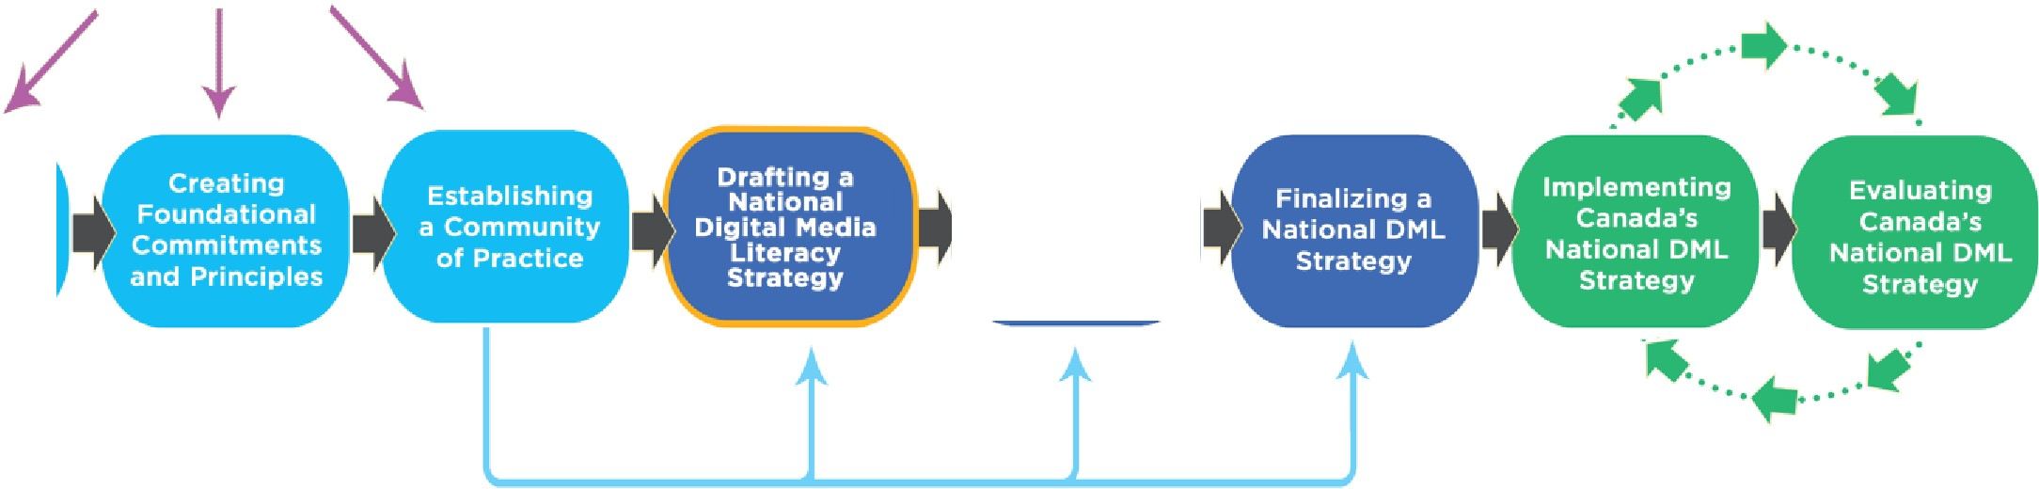Building Context
Mapping Canada's DML Service Landscape

26

Moving forward

MediaSmarts has been advocating for a digital media literacy strategy for over fifteen years - a recommendation consistently endorsed by key stakeholders and community partners and re-confirmed both during and after participation in the symposium in February 2022. Individuals, organizations and leaders in the field are eager to move forward on some next steps and are aware that this will involve ongoing consultation, communication and collaboration.

This project allowed us to take important first steps towards developing a national digital media literacy strategy. The environmental scan from phase one provides essential context around the history of policymaking and advocacy in this area from across Canada and presents strategies, models and frameworks from other jurisdictions that can influence and support our ongoing work. Next, the symposium event allowed us to focus more intentionally on the Canadian context and assess needs based on information and experiences from various organizations and community stakeholders.

After identifying needs and concerns related to digital media literacy in Canada, we were able to create ten foundational commitments and principles to facilitate the development of a national strategy. Finally, the establishment of a Community of Practice ensures that digital media literacy champions, stakeholders, experts, service providers and practitioners from across Canada will continue to connect in ways that supports not only the development, implementation and evaluation of a strategy, but also the work of various community-based groups and organizations.

The symposium event set the stage for the remaining elements of the roadmap. The outcomes of the event - as we have presented in this report - highlight the need for ongoing communication and collaboration. We will continue to work with partners and seek additional resources that will allow the Community of Practice to take the next steps in developing and implementing a national digital media literacy strategy in Canada. These steps could include:

Conducting a thorough mapping of the digital media literacy service landscape across Canada. This detailed mapping of the field is essential and will deepen understanding of community-based organizations, their work related to digital media literacy and where the needs and challenges are - especially for priority groups.

Finalizing a national digital media literacy strategy in consultation with and reviewed by the Community of Practice.

Developing an implementation and evaluation plan to monitor and regularly adapt the strategy.

A national strategy must continue to centre the insights and experiences of those who work within communities across Canada and who understand the immediate digital media literacy needs of the individuals and families who access their programs.

The Community of Practice established through this project demonstrates an already expansive network of service providers and other partners who value and promote the key elements present within the foundational commitments and principles outlined in this report, like equity, inclusion, accessibility and digital well-being.

Finally, this work must be supported by consistent funding through processes that do not amplify the competition between community-based organizations. Instead, funding structures should foster collaboration and recognize the value of investing appropriately in various resources to meet the needs of communities. Part of the solution here requires that the strategy finds a home in the federal government - in a department through which funding is disseminated directly to community-based organizations. For example, we have already highlighted the United Kingdom's Online Media Literacy Strategy that sits with the Department for Digital, Culture, Media & Sport. This ownership of the plan assures a commitment from the government to
"take action against the identified challenges and respond to the changing needs of the media literacy sect or." MediaSmarts will continue to advocate for such an approach in Canada, to ensure digital media literacy initiatives receive ongoing support and engagement from all levels of government.

Developing a national digital media literacy strategy is an essential project and MediaSmarts remains excited by and committed to this challenge - especially after the symposium where the need for a made-in-Canada strategy was confirmed by community partners. We look forward to continuing conversations, making progress on the next steps and bringing what has long been a policy imperative of the Canadian digital media literacy sector to fruition.

A national strategy will provide experts, advocates and service providers in the digital media literacy field with a unified but flexible approach for preventing and responding to online harms through education and critical skills development. At the same time, people living in Canada will be empowered to use, understand, create and engage with digital technology and digital media, which is at the heart of active digital citizenship and innovation.

Appendices

Appendix A: Competencies, key concepts and topics

COMPETENCIES

Access, use, understand and engage are the essential competencies that make up digital media literacy. The model below illustrates how these principles are interrelated. Access functions as the base or precondition of digital media literacy. However, there are skills associated with access, as well: finding relevant information or media, using accessibility tools and safely making use of public internet access facilities, for example. Use, understand and engage represent the fluency, skill, competency and ability required to be an active and ethical digital citizen.

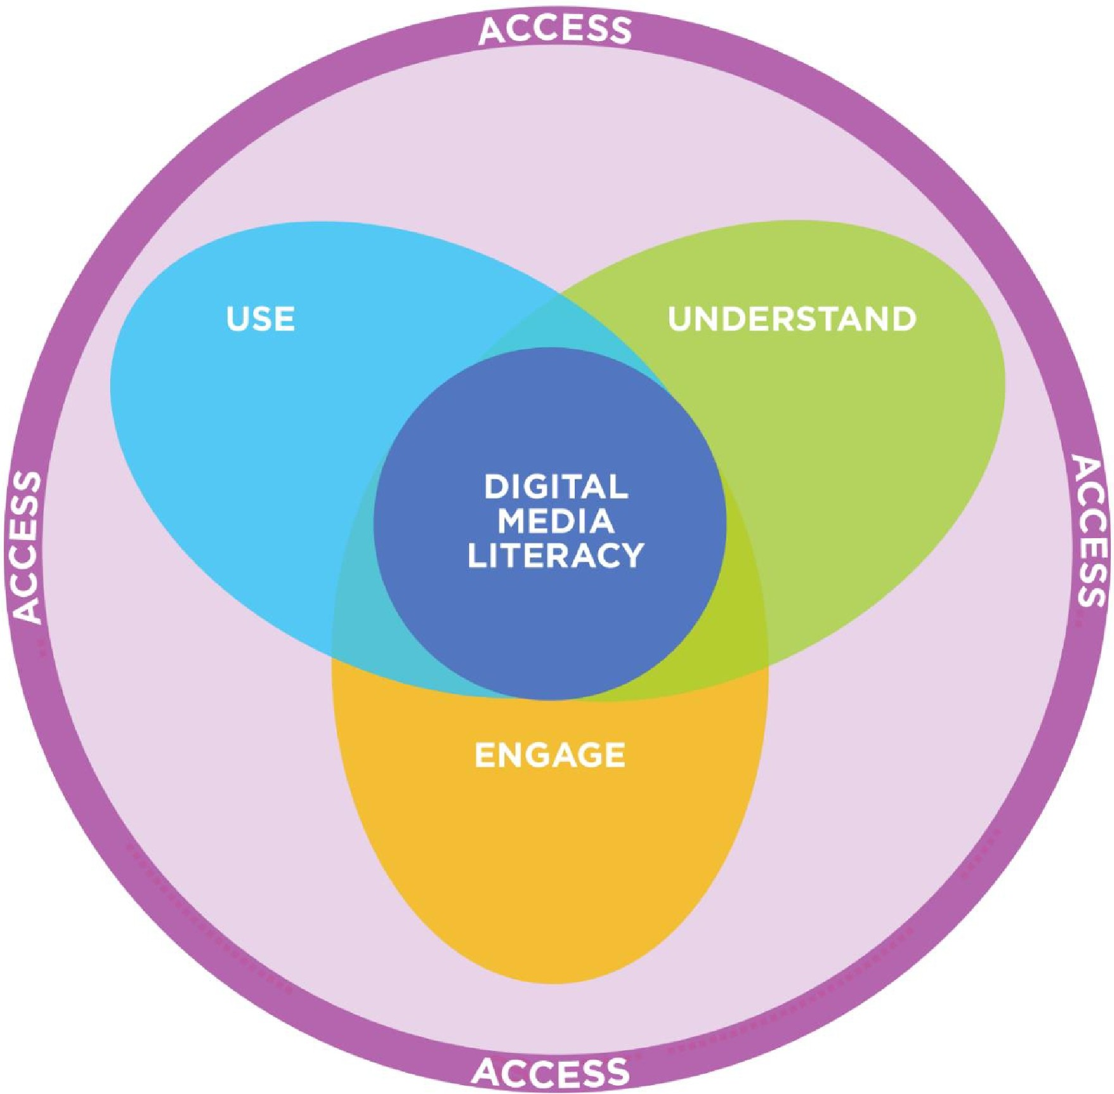

KEY CONCEPTS

Key concepts provide a lens for analyzing any media work, platform or experience and are used to develop relevant questions about media. MediaSmarts' digital media literacy model incorporates a version of the original key concepts of media literacy developed in the 1980s for use in the K-12 school system:

Media are constructions that were made by people for particular purposes and reflect the choices and assumptions of those people and the limits on those choices.

Media have commercial implications because most media are created to earn money (even if, as in the case of social media content, the creator may not be the one earning money) and nearly all cost money to make.

Media have social and political implications because we see them as reflections of reality. Therefore, who is represented (both on and behind the screen), whose voices are heard and what values are presented as important strongly influence us individually and collectively.

Audiences negotiate meaning of media works. We all bring our own identities and experiences to a work, which often leads different people to interpret the same work differently.

Each medium has a unique aesthetic form or, in the words of media scholar Marshall McCluhan, "the medium is the message." Media (and genres) each have their own ways of communicating meaning and directing our attention, which must be understood to critically "read" a media text.

MediaSmarts has also developed five key concepts specific to digital media. These are needed to account for the fact that digital media are networked rather than flowing in a single direction from a small number of creators and distributors to many isolated consumers, as traditional media does, digital media has a two-way flow that connects every user and makes them simultaneously consumers, creators and broadcasters.
The remaining key concepts of digital media are implications of this:

Digital media are shareable and persistent. Because the "distribution" of digital media actually involves making copies and because of the infinite web of two-way connections between users, distribution of content (which in traditional media is often the most expensive element) becomes virtually free and frictionless. As a result, sharing becomes the default and there is seldom just a single copy of anything.

Digital media have unexpected audiences which may see content not intended for their eyes. The lifespan of digital content also means that these audiences may be seeing the material long after it was created. Because digital media are networked, it is easy for audiences to consume content they did not expect or intend to see.

The two-way, networked quality of digital media also means that interactions through digital media have real impact. Unlike traditional media, which offered few opportunities for interaction, our experience of digital media is much more

participatory - which has implications ranging from cyberbullying to dramatically increased opportunities for civic engagement.

Finally, digital media experiences are shaped by the tools we use. Just as the features, limitations and history of each medium influences its content, the affordances and defaults of any digital tool influence our use of it by making certain actions easier, more difficult, required or expected.

TOPICS

Finally, MediaSmarts has identified nine topics that make up the essential content knowledge of digital media literacy:

Reading media: How different media and genres tell stories and communicate meaning, such as camera angles and editing in film, panel composition and transitions in comics and user interface and hyperlinks in online media.

Media representation: How media represent reality and how different audiences respond to those representations, covering topics such as stereotyping, how media shape our views of the world and ourselves and how we represent ourselves on social media.

Media health: How both using and consuming media can affect our physical and mental health.

Community engagement: Knowing our rights as citizens and consumers and how we can influence positive social norms in online spaces and to speak out as active, engaged citizens.

Consumer awareness: The commercial aspects of the media we use and consume, including how to navigate the corporate spaces in which we interact online and how advertising messages manipulate us.

Making and remixing: How to make media and use existing content for our own purposes in ways that respect legal and ethical considerations.

Finding and verifying: How to effectively search the internet for information we need for personal and school purposes and then evaluate, authenticate and critique sources and information.

Ethics and empathy: Managing our interactions with other people through digital media and how to make ethical decisions when dealing with issues such as cyberbullying, sharing other people's content and accessing music and video.

Privacy and security: Managing our privacy, reputation and security online by making good decisions about what we share; understanding data collection and making active choices about it; protecting ourselves from malware and other software threats and being aware of our digital footprint.

Appendix B: Key informant interviews

MediaSmarts conducted six interviews as part of our environmental scan:

- Dr. Julian Thomas from the Australian Digital Inclusion Alliance
- Dr. Tim Winklemans from the British Columbia Ministry of Education (retired)
- Annabel Astbury from the Australian Media Literacy Alliance
- Dr. Yuhyun Park from the DO Institute
- Dr. Nancy Law from UNESCO
- Rachel Beggs from the UK Department for Digital, Culture, Media & Sport

Guiding questions:

- What are the best practices for designing and implementing a national digital media literacy strategy?

- What unique factors must be considered in the Canadian context?

- What potential barriers to digital media literacy must be considered? What are potential solutions to these barriers?

- How is digital citizenship conceived and experienced by equity-deserving groups? What are the considerations to be made in a national digital media literacy strategy?

- What stakeholders and community partners need to be consulted in building a national digital media literacy strategy? What is their role?

Appendix C: Symposium participants

ABC Life Literacy

Atlantic Equity and Research Alliance Canadian Civil Liberties Association Canadian Commission for UNESCO Canadian Internet Registration Authority
Canadian School Libraries
Centre quebecois d'education aux medias et a !'information Department of Canadian Heritage (observer)
DigitalNWT

LEAF: Women's Legal Education and Action Fund Neil Squire Society
Nia Centre for the Arts

Normand Landry, Universite TELUQ

Office of the Privacy Commissioner of Canada

Public Safety Canada (Canada Centre; Online Child Sexual Exploitation) Project Someone, Concordia University
Rideau Hall Foundation Ryerson Leadership Lab Samara Centre for Democracy SecDev Foundation
Simon Fraser University Universite du Quebec a Montreal University of Ottawa
University of Toronto

Appendix D: Symposium agenda

Symposium
From Access to Engagement:
A Digital Media Literacy Strategy for Canada

ACENDA

Welcome from MediaSmarts
9:00 - 9:10

Housekeeping
9:10-9:15

Plenary panel
9:15 - 9:45

BREAK
9:45 - 9:50

Lead-in to first breakout session
9:50 - 9:55

9:55 - 10:35
Breakout session:
- Brainstorming
the commitments and principles

Back to group
10:35 - 10:45

BREAK
10:45 - 11:00

Lead-in to second breakout session
11:OO - 11 :OS
Breakout session:
- Building the commitments and principles

11 :OS - 11 :45

Back to group
11:45 - 1 2:00

Wrap-up and next steps
1 2:00 - 1 2:25

Thank you from MediaSmarts
1 2:25 - 1 2:30

